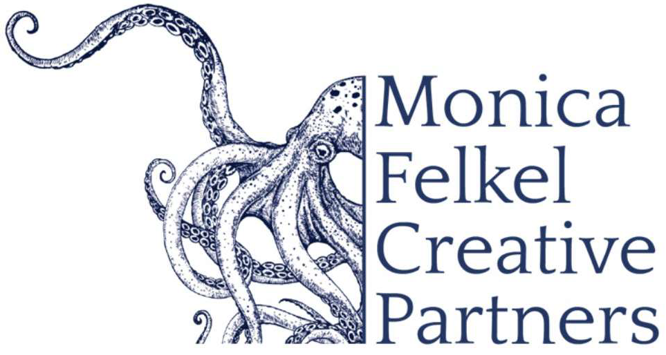
www.monicafelkelcreativepartners.com
Jonathan Swensen
Concerto Repertoire

J.C. BACH / CASADESUS Cello Concerto in C minor

BEETHOVEN Concerto for Violin, Cello, and Piano in C major, Op. 56

BLOCH Schelomo

BRAHMS Double Concerto in A minor, Op.102

DUTILLEUX Tout un monde lointain

DVOŘÁK Concerto in B minor, Op.104

ELGAR Concerto in E minor, Op.85

FELDMAN Cello and Orchestra

GULDA Concerto for Cello, Wind Orchestra and Band, Op. 129

HAYDN Concerto No.1 in C major, Hob.VIIb/1
Concerto No. 2 in D Major, Hob. VIIb/2, Op. 101

KHACHATURIAN Concerto-Rhapsody

LALO Concerto in D minor

LUTOSŁAWSKI Cello Concerto

ROXANNA PAUFNIK Orpheus: To Hell and Back Again*. June 2026 world premiere
*This concerto will be double billed with William Schuman's 'A Song Of Orpheus'

SAINT-SAËNS Concerto No.1 in A minor, Op.33

SCHUMANN Concerto in A minor, Op.129

SHOSTAKOVICH Concerto No.1 in E-flat major, Op.107 Concerto No.2, Op.126

SOLLIMA “Violoncelles Vibrez!”

TCHAIKOVSKY Rococo Variations, Op.33
Pezzo Capriccioso, Op.62

WEINBERG Cello Concerto in C minor, Op. 43

Please enquire about repertoire that may not be listed at this time.

